# **Lights Out Puzzle Documentation**

## Requirements

Lights Out Puzzle must have a 5 by 5 grid using .Net environment. The puzzle must start with some lights on. In order to win the game, the player has to turn off all lights. Upon winning, the application will show a message box that the player has won.

## Design

Windows Forms will be used to develop the game by utilizing the TableLayoutPanel, which will have a grid of 5 by 5 filled with a button in every cell. This Panel will facilitate the process to know which button was clicked and its adjacent cells. All the buttons will have the same click event that will invert the colours between black and aqua. The same process is also applied to the adjacent neighbours. Apart from the colour, there will be a 2D array Boolean representing the state of every cell that must be also updated. At the end of the click event, there is a check which will display a message box that the user has won the game.

At the start of the game some lights must be turned on, this will be tackled by generating a random number between 1 and 6. The result of the random number will decide how many lights will be turned on from the 25 cells in the grid. Their position will be chosen based on 2 random numbers which will select the column and row position relative to the grid.

## User Interaction

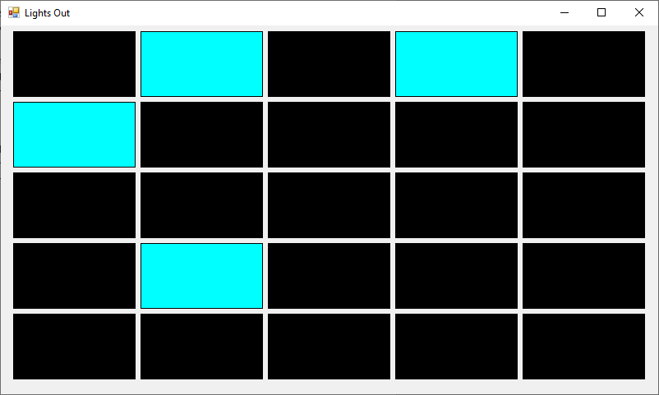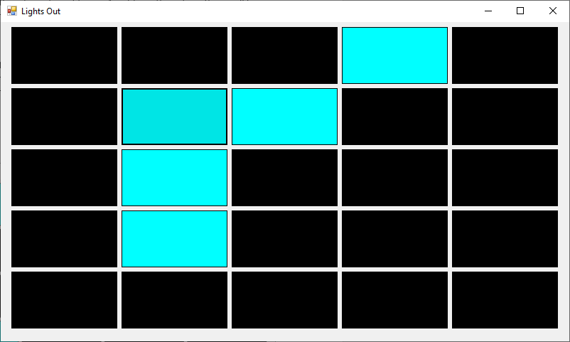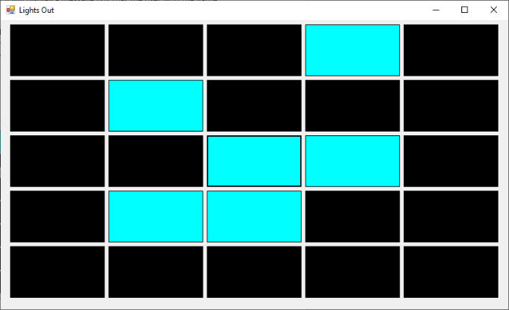

## Test Cases

|  |  |
| --- | --- |
| Test Case 1 | |
| Test Case Description | Check that upon loading the game there is 1 or more, up to 6 cells turned on. This check must be iterated for 10 times. |
| Expected Result | A minimum of 1 cell up to 6 are turned after launching the game 10 times |
| Result | PASS |

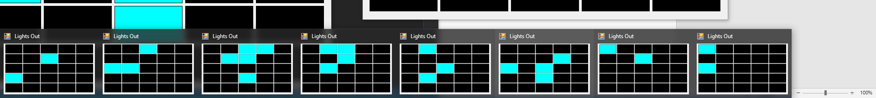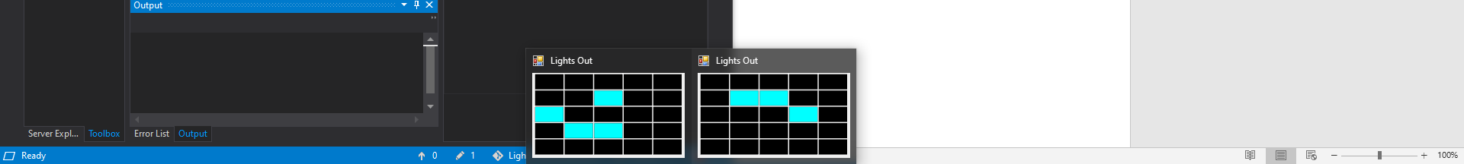

|  |  |
| --- | --- |
| **Test Case 2** | |
| **Test Case Description** | Check that the lighted cells are randomly spread in the grid |
| **Expected Result** | Lighted cells must be randomly spread over the grid |
| **Result** | PASS |



|  |  |
| --- | --- |
| **Test Case 3** | |
| **Test Case Description** | Check that turned off cells when selected, are turned on |
| **Expected Result** | Cells must be turned on |
| **Result** | PASS |

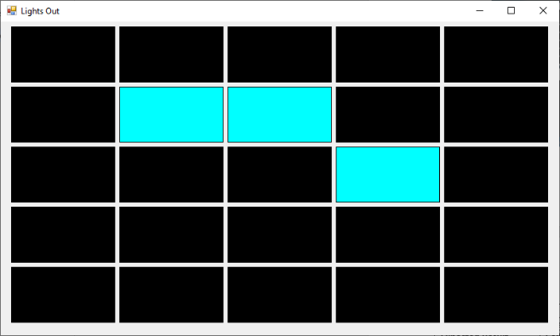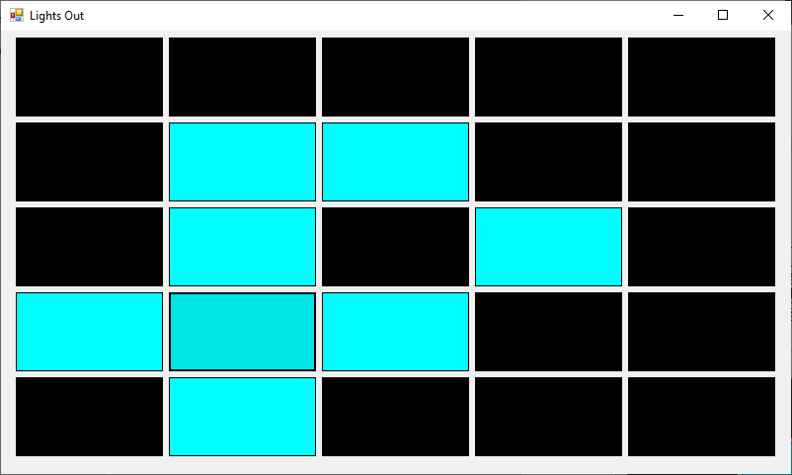

|  |  |
| --- | --- |
| **Test Case 4** | |
| **Test Case Description** | Check that adjacent cells of selected cell are also turned on when they are off |
| **Expected Result** | Cells are turned on |
| **Result** | PASS |



|  |  |
| --- | --- |
| **Test Case 5** | |
| **Test Case Description** | Check that adjacent cells of selected cell are also turned off when they are on |
| **Expected Result** | Cells are turned off |
| **Result** | PASS |



|  |  |
| --- | --- |
| **Test Case 6** | |
| **Test Case Description** | Check that the invert of lights is working when clicking a cell which is turned off and some of the adjacent cells turned on |
| **Expected Result** | Cells that are turned on should be turned off and those that are off should be turned on |
| **Result** | PASS |

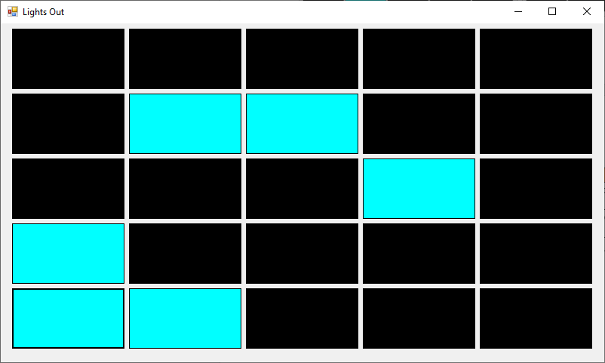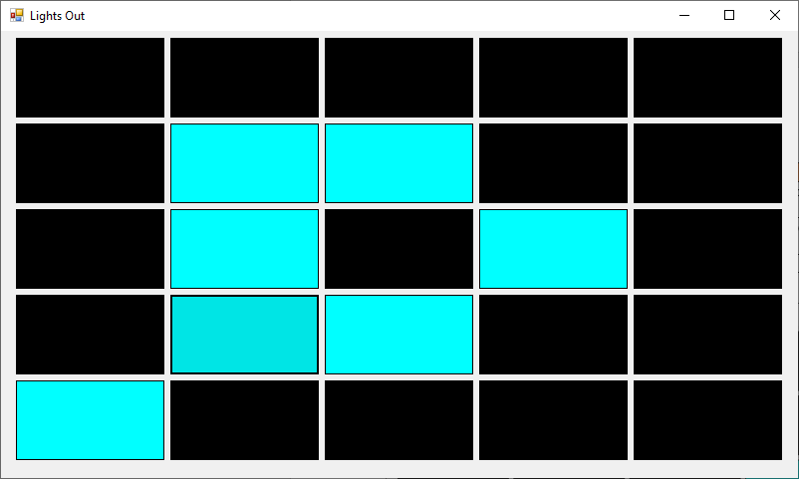

|  |  |
| --- | --- |
| **Test Case 6** | |
| **Test Case Description** | Check the behaviour of the game when not clicking on the cells |
| **Expected Result** | The game should not react to those event |
| **Result** | PASS |



|  |  |
| --- | --- |
| **Test Case 6** | |
| **Test Case Description** | Check if the message is shown if the user manages to win the game |
| **Expected Result** | User will be shown a message that he won |
| **Result** | PASS |

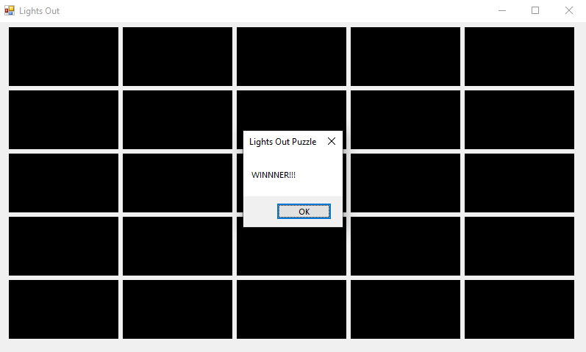

|  |  |
| --- | --- |
| **Test Case 6.1** | |
| **Test Case Description** | Check that after winning the game, the player can play again |
| **Expected Result** | Some lights will be randomly turned on as if the game has just started |
| **Result** | Fail |

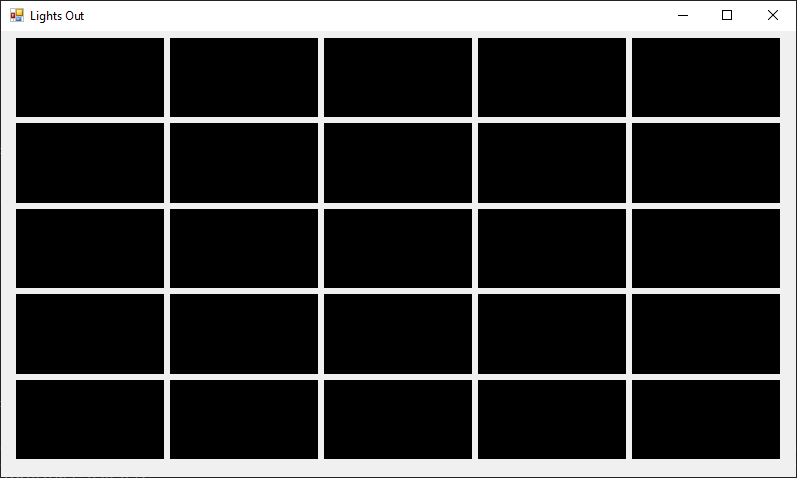

|  |  |
| --- | --- |
| **Test Case 6.2** | |
| **Test Case Description** | Check that after winning the game, the player can play again |
| **Expected Result** | Some lights will be randomly turned on as if the game has just started |
| **Result** | Pass |

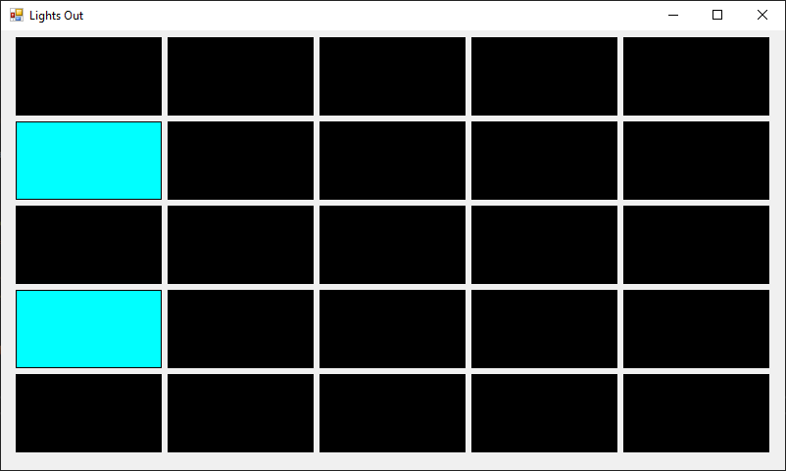



|  |  |
| --- | --- |
| **Test Case 7** | |
| **Test Case Description** | Check that randomly pressing cells will not crash the game |
| **Expected Result** | Application did not crash |
| **Result** | Pass |

|  |  |
| --- | --- |
| **Test Case 8** | |
| **Test Case Description** | Check that continuously pressing cells fast does not affect the game performance |
| **Expected Result** | Performance of the game will not be affected |
| **Result** | Pass |

## Future Enhancements

To further the user experience during the game, the grid should be dynamic based on the player’s choice while also tracking how many moves and time taken to solve the game. This will increase the competitive aspects of the game which make the game more enjoyable. In terms of UI, some artwork should be included for example showing lightbulbs instead of buttons.